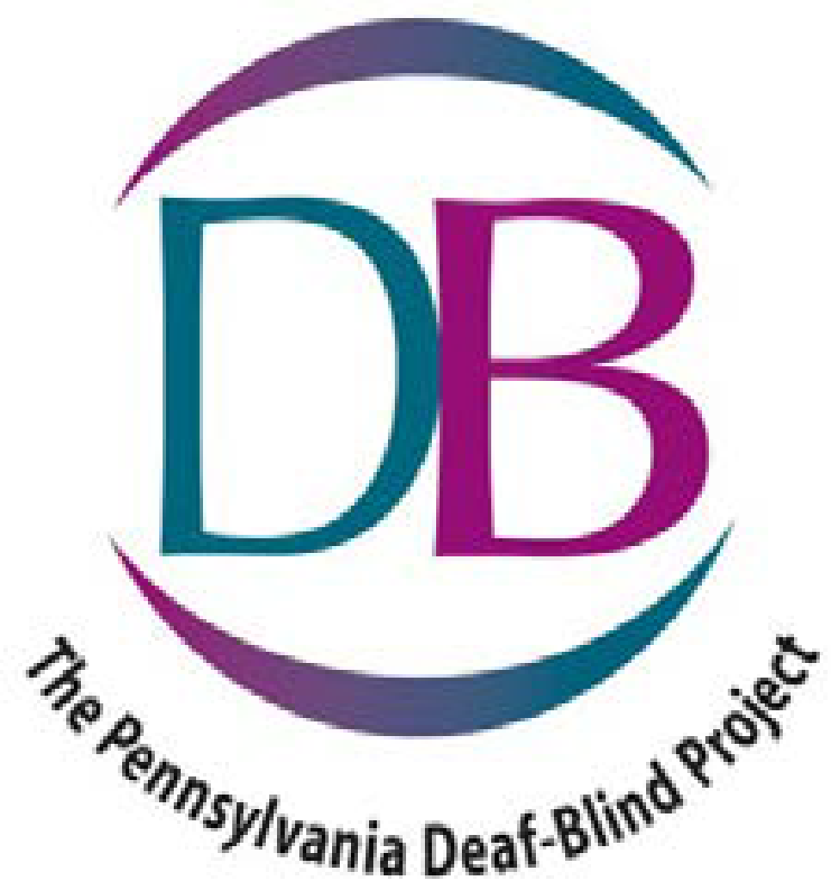SAVE THE DATE
2023
Family Learning
Conference
June 23 & 24, 2023
Penn Stater
Hotel & Conference Center
215 Innovation Blvd., State College, PA 16803

If your child has both a vision and hearing loss, your family (parents/guardians, siblings and child with deaf-blindness) may be eligible to attend a weekend learning conference
(at little or no cost).
Come experience sharing, caring, and learning together with staff from the Pennsylvania Deaf-Blind Project, PaTTAN, and other families living with deaf-blindness.
Please be watching for more details in the new year!

